**Project: Airline Ticket Reservation in PHP with source code**

**Source file link: https://code-projects.org/airline-ticket-reservation-in-php-with-source-code/**

-To download **Airline Ticket Reservation In PHP** project for free(Scroll Down)

The Airline Ticket Reservation In PHP is a simple reservation system for flights. The project contains the admin side and the user side. The admin can view and manage the users, add/modify the flight schedule, view the booked ticket and manage the flight details.

The users are the clients who want to search and reserve the flights suitable for them. A user has to login first to make the reservation. If he/she has not registered, they can register first and then login. A user can search for available flights for a particular city-pair and book tickets in the class of their choice. This project is a very simple project that saves time and money for the customer as well as the airline company thereby making air travel more customer-centric.

#### **About System**

This Airline Ticket Reservation is in PHP, CSS, JavaScript, and bootstrap. Talking about the features of the Airline Ticket Reservation, it just contains both the admin section and the user section. The user can log in to book flights, while the admins can view all users’ bookings and manage the flight schedules. The design of this project is pretty simple so that the user won’t find any difficulties while working on it.

#### **How To Run The Project?**

To run this project, you must have installed a virtual server i.e [XAMPP](https://www.apachefriends.org/download_success.html) on your PC (for Windows). This Airline Ticket Reservation in PHP with source code is free to download, Use for educational purposes only!

***After Starting Apache and MySQL in XAMPP, follow the following steps.***

***1st Step:*** Extract file  
***2nd Step:*** Copy the main project folder  
***3rd Step:*** Paste in xampp/htdocs/

***4th Step:*** Open a browser and go to URL “http://localhost/phpmyadmin/”  
***5th Step:*** Then, click on the databases tab  
***6th Step:*** Create a database naming “airline_reservation” and then click on the import tab  
***7th Step:*** Click on browse file and select “airline_reservation.sql” file which is inside the “Database file” folder  
***8th Step:*** Click on go.

***After Creating Database***,

***9th Step:*** Open a browser and go to URL “http://localhost/ airline-ticket-reservation/home_page.php”

**Note:** For **Admin login details: (admin, admin)**

**Mockup Screens**

Home page

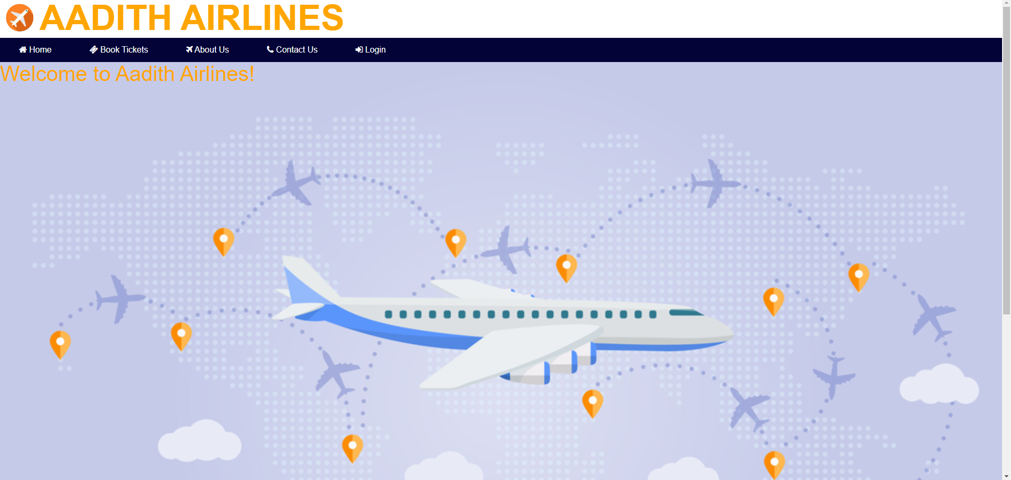

Ticket booking

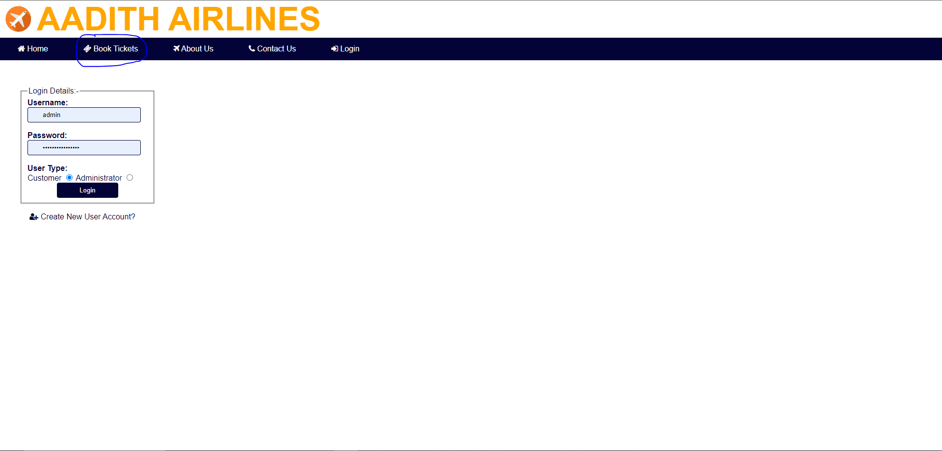

Login

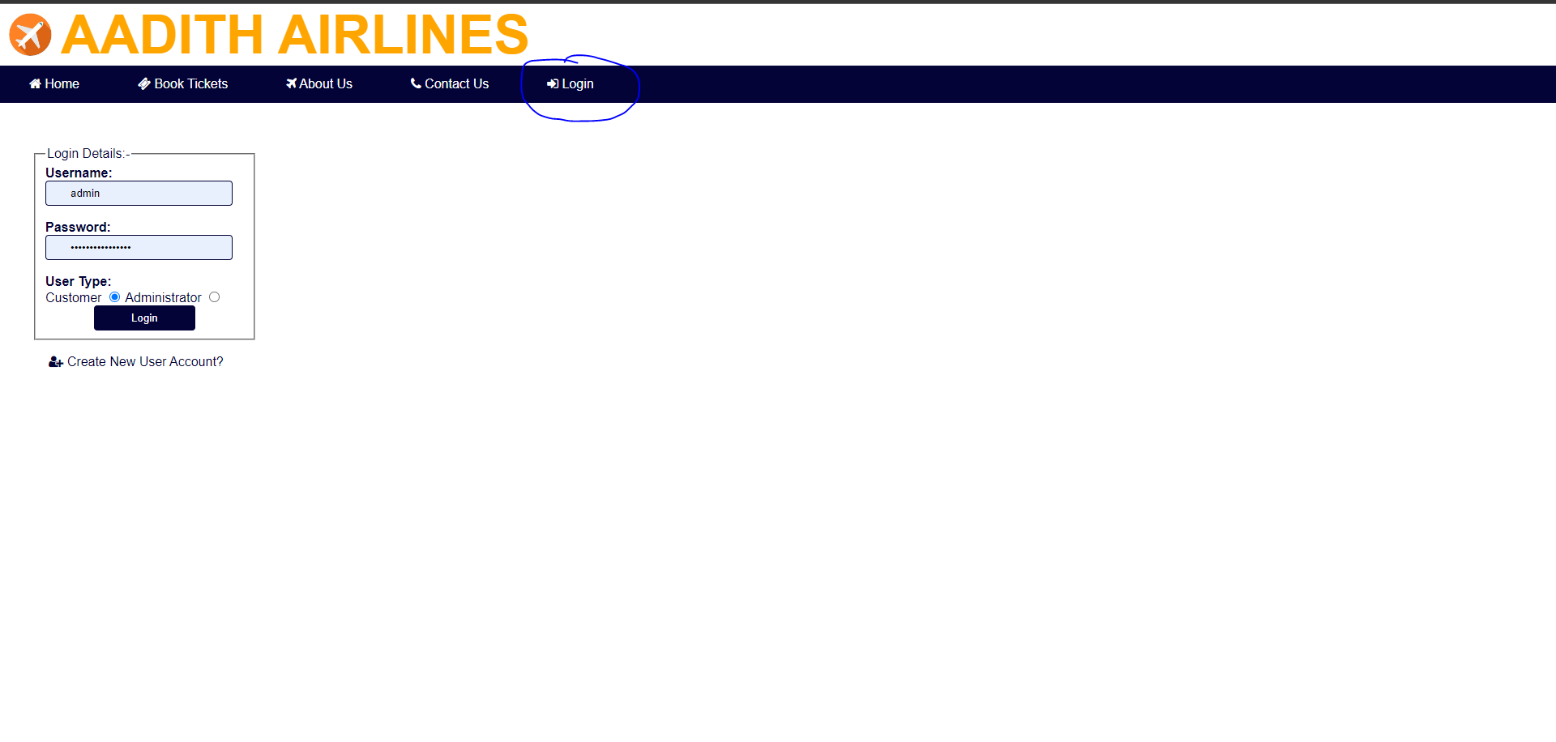

Admin page

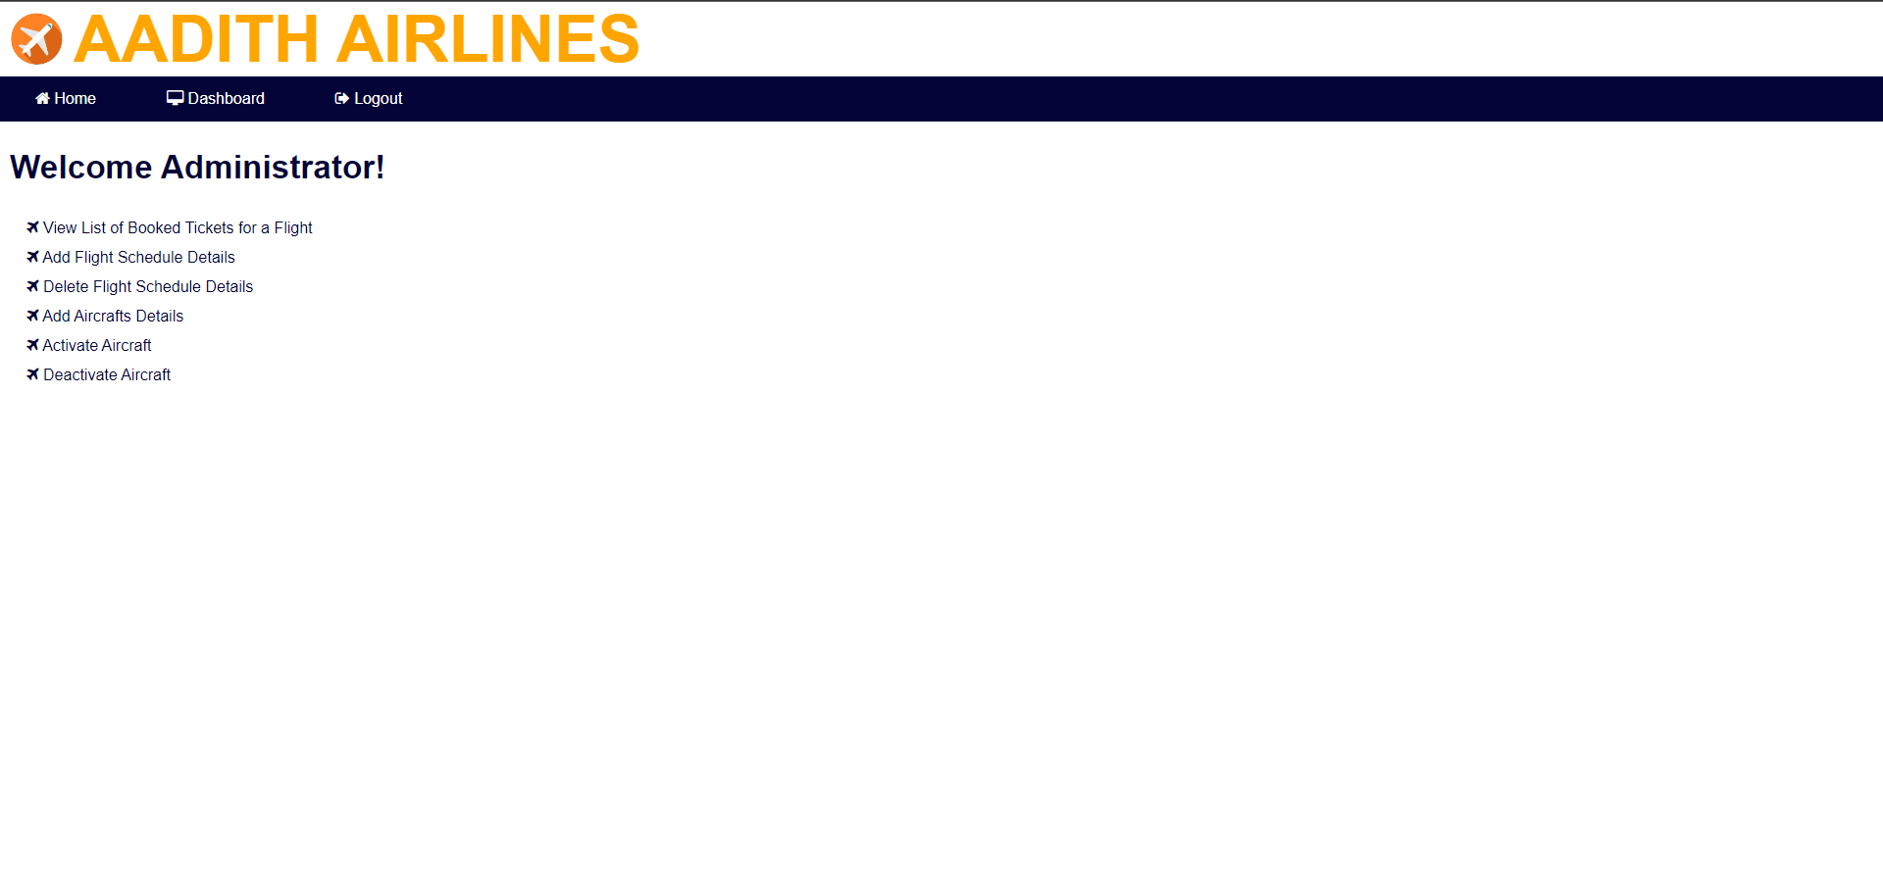

Admin > view list of booked tickets

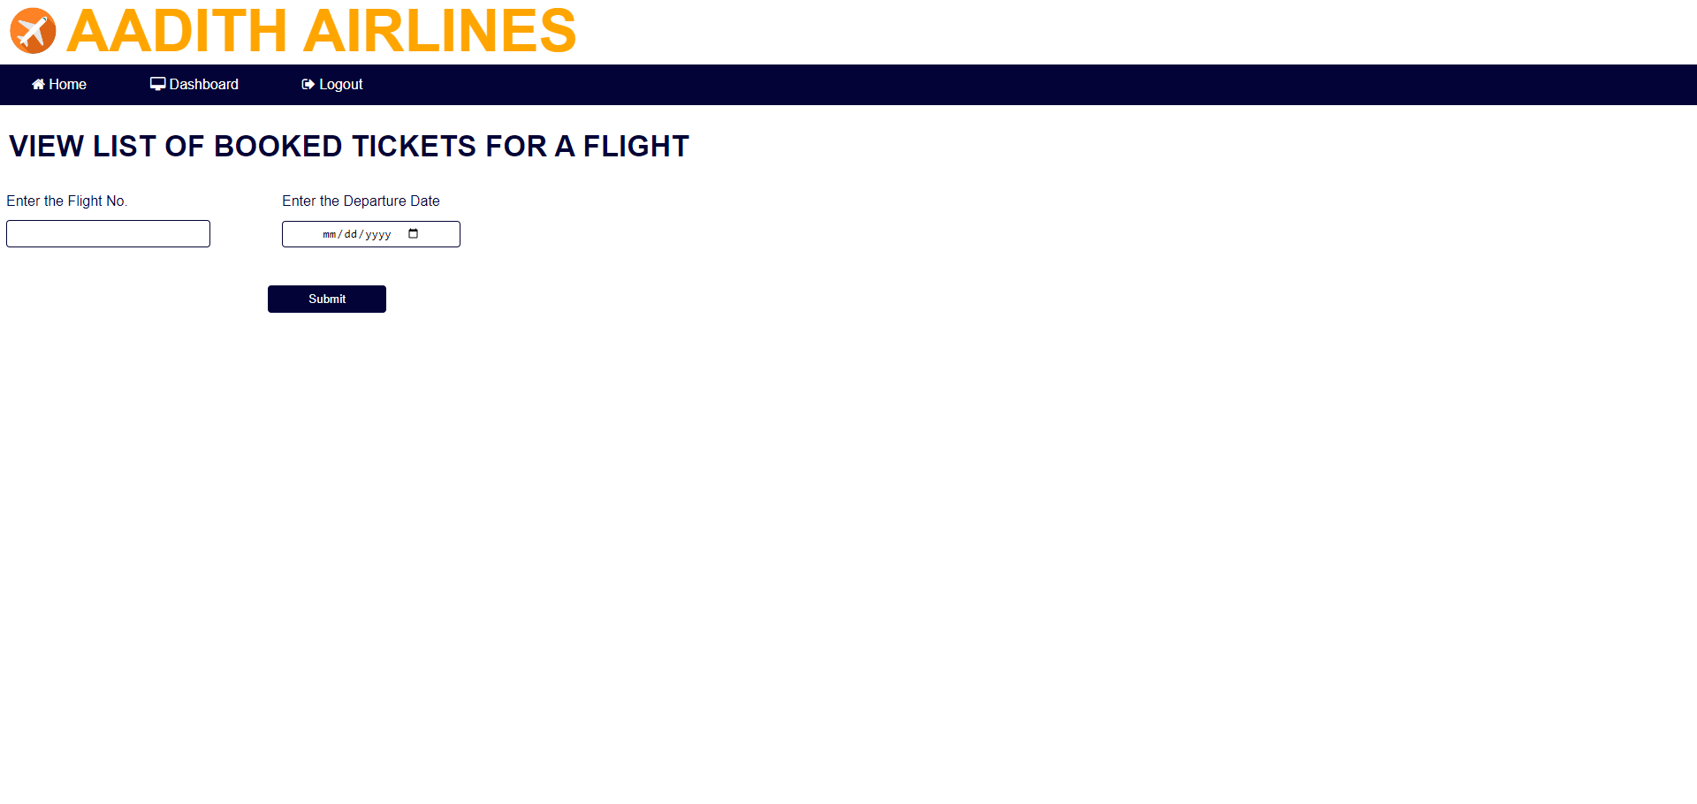

Admin > add schedule



Admin > schedule deletion

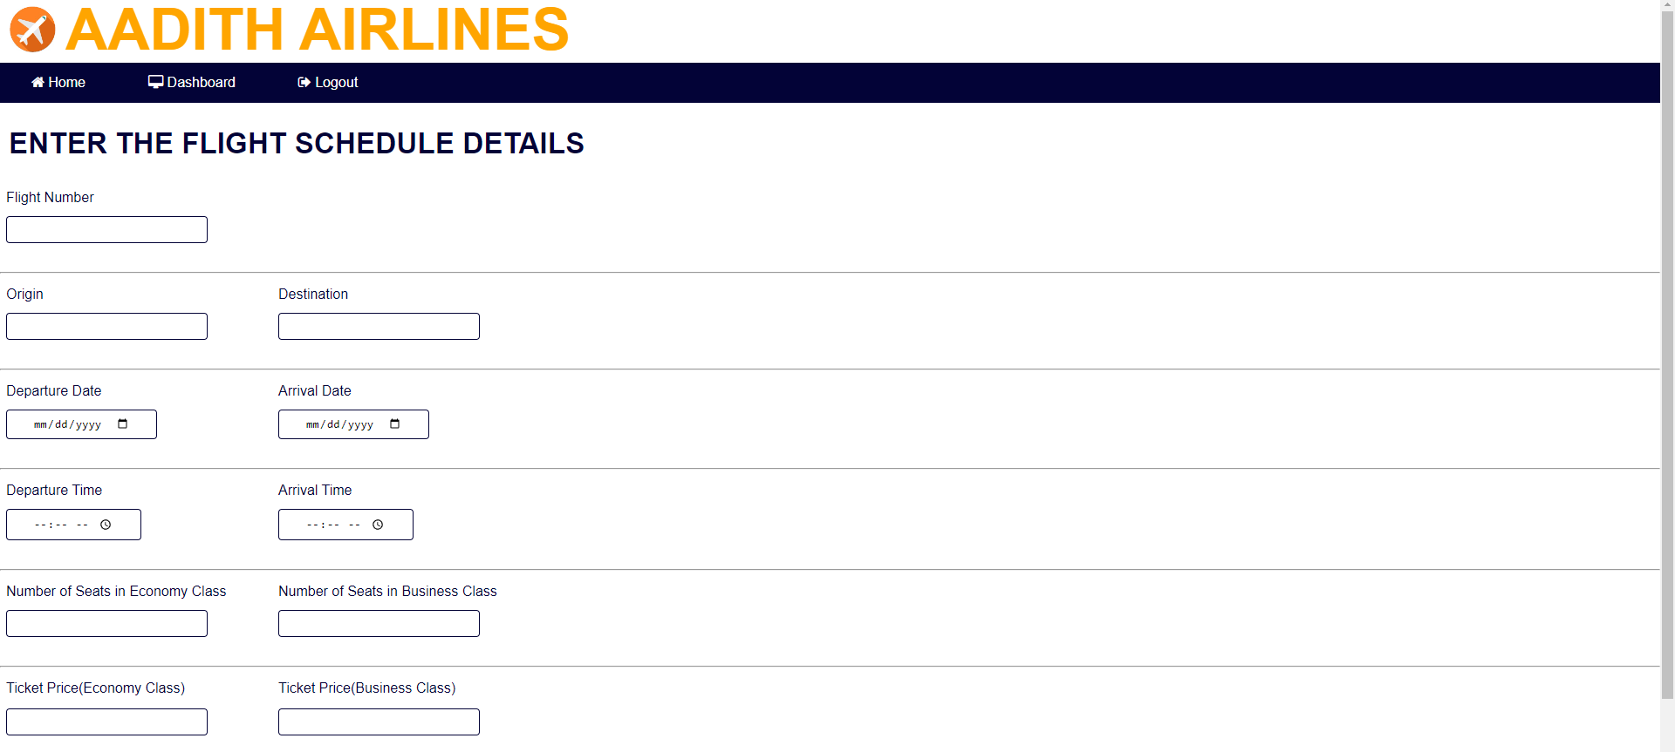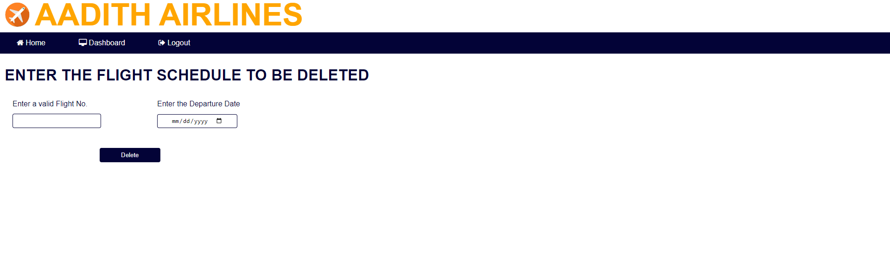

Admin > add aircraft section

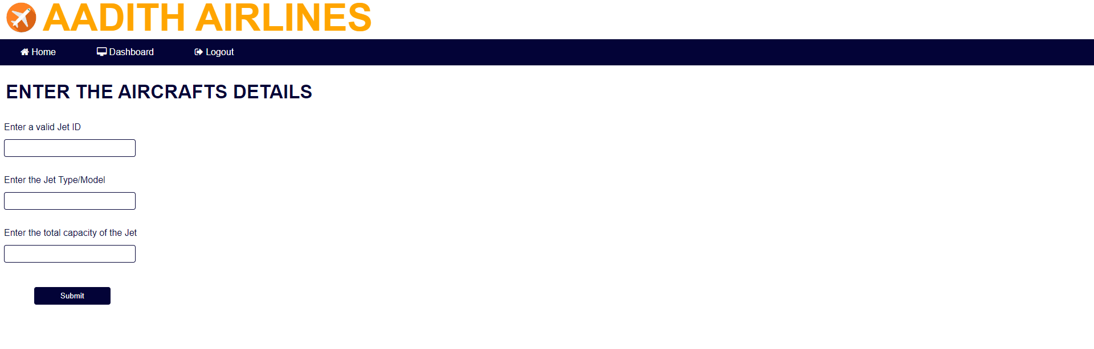

Admin > activate aircraft section

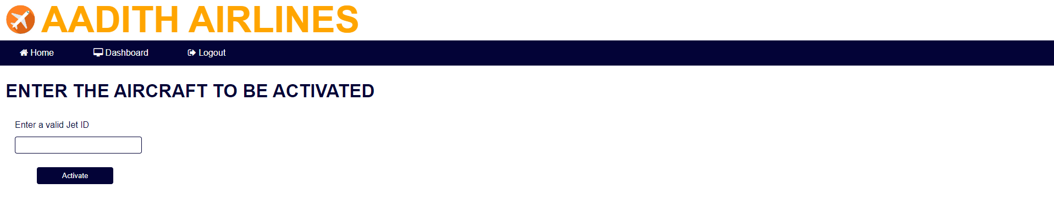

Admin > Deactivate aircraft section

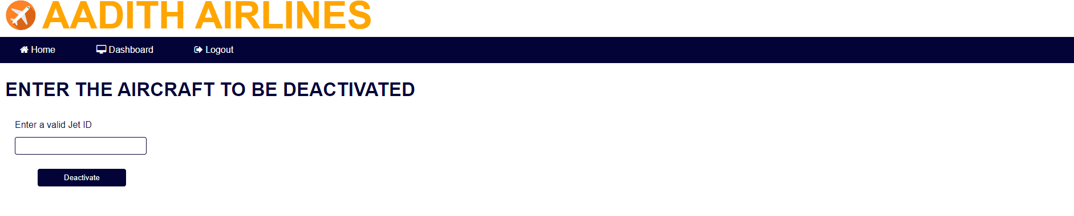

Customer page:

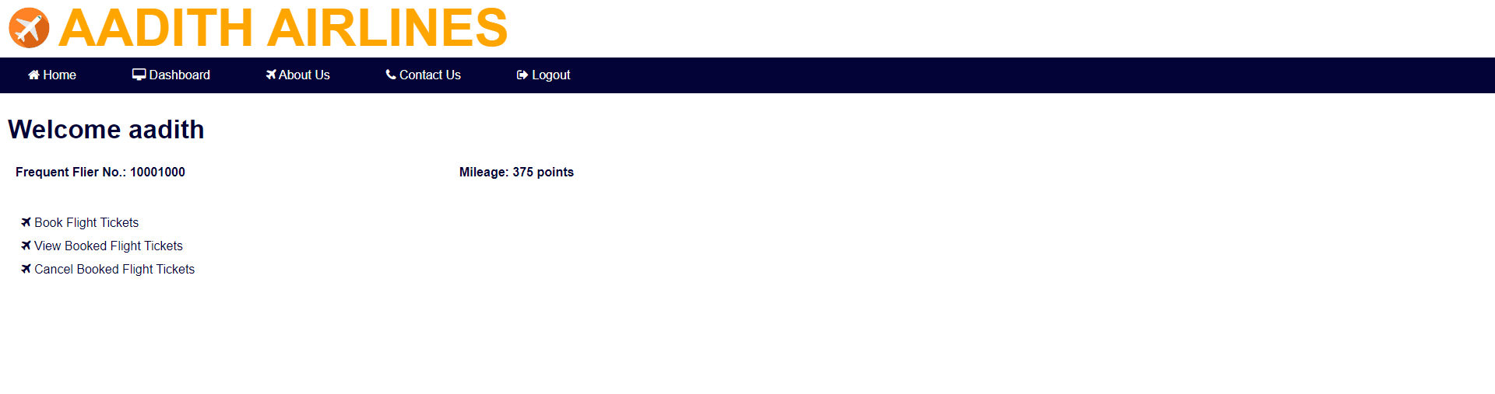

Customer registration page:

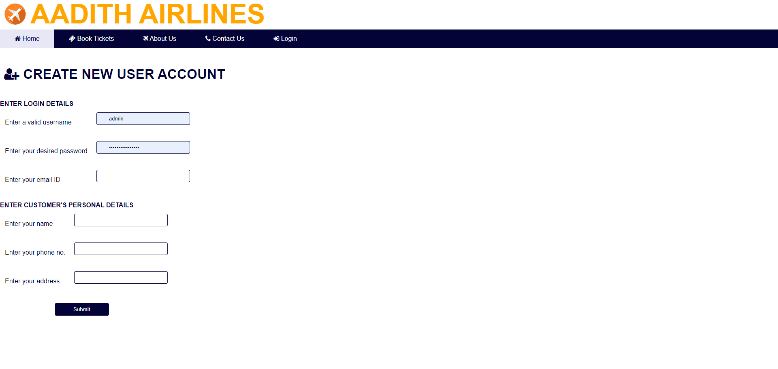

Customer page> book flight tickets

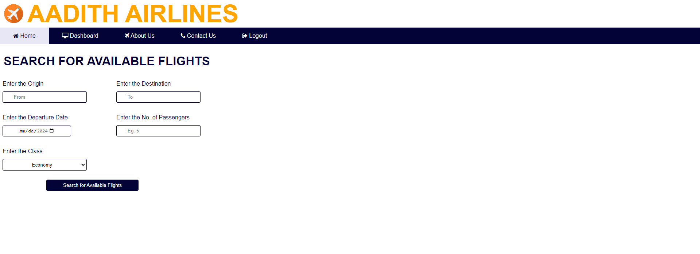

Customer page> view flight tickets

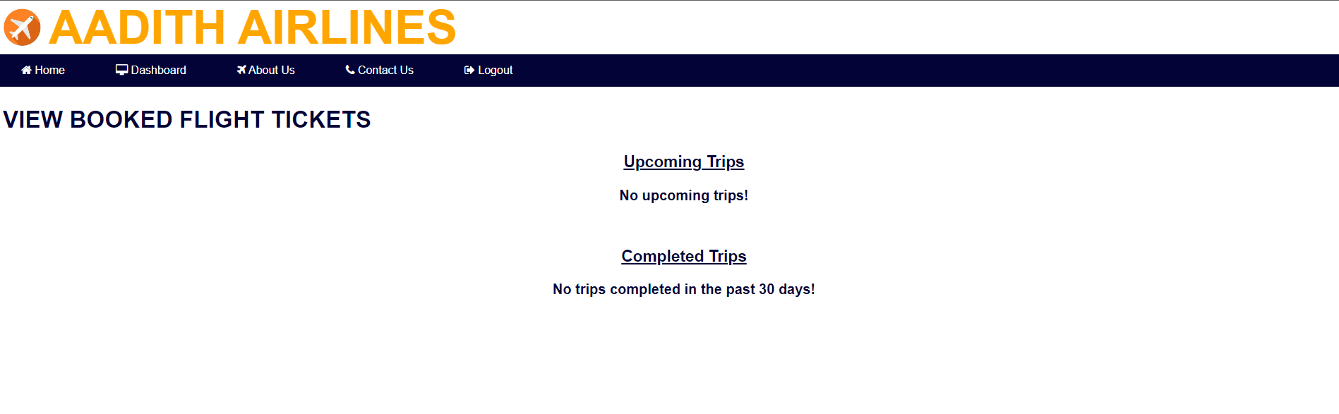

Customer page> cancelflight tickets

